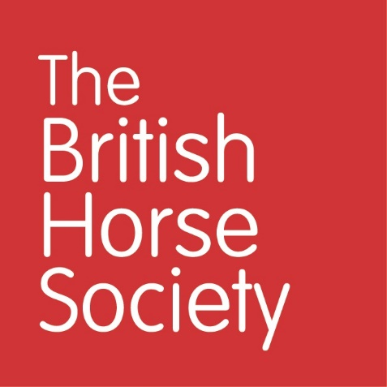

Horse Care & Welfare Volunteer Coordinator

Full Time Permanent position - 35 hours per week
Salary: circa £24,000 Per Annum

Based at our HQ near Stoneleigh, Warwickshire (hyrbid working from home and office)
The British Horse Society is the nation’s largest equine charity with a passion for horses that is backed by knowledge and expertise. The BHS represents and provides a range of services for horse riders, horse owners, enthusiasts and professionals.
We are looking for a Horse Care & Welfare Volunteer Coordinator. This role is required to contribute to the success of the Horse Care & Welfare Department in its aim to prevent breaches of equine welfare by recruiting, training and supporting the BHS volunteer network of Horse Care & Welfare Volunteers. The successful candidate will be overseeing both of our Welfare based volunteer roles; Horse Care & Welfare Advisers, and Friends At The End volunteers.
You will have the responsibility for our Horse Care & Welfare Advisers recruitment process which will include organising, promoting, and delivering a schedule of virtual training sessions as well as face to face when needed. You will work closely with our team of employed Horse Care & Welfare Field Officers as well as our Volunteer Department. You will have excellent equine knowledge and be confident in developing our existing Horse Care & Welfare Adviser role to encompass wider proactive welfare education activities. You will be confident in supporting Horse Care & Welfare Advisers through challenges faced in the field and be able to offer help with any queries or concerns regarding their role. You will also manage the recruitment process, and the e-Learning training platform for our other volunteer role, Friends At The End.
We are looking for someone who has experience of coordinating and supporting volunteers as well as excellent equine knowledge. You will need to have access to a vehicle suitable for business use, as travel to remote locations / locations inaccessible via public transport will be required. You must have a flexible attitude to travelling around the UK and to undertaking occasional weekend and evening work.

The British Horse Society is committed to the equal treatment of all current and prospective employees and does not condone discrimination on the basis of age, disability, sex, sexual orientation, pregnancy and maternity, race or ethnicity, religion or belief, gender identity, or marriage and civil partnership.
We aspire to have a diverse workforce because, in our view, diversity enables better organisational outcomes. We also believe that a more inclusive workplace, where people of different backgrounds work together, ensures better outcomes for all employees. We therefore strongly encourage suitably experienced people from a wide range of backgrounds to apply.
Only suitable candidates will be directly contacted about this position and we will not store or process the data of candidates in any way unless consent has been obtained.
We would encourage you to submit your CV as early as possible if you are interested in working with us, as we may stop accepting applications before the currently advertised closing date if we receive a large number of suitable applications.

To apply please provide a covering letter and CV, highlighting relevant skills and experience and send along with your application to jobs@bhs.org.uk For further details of this and other opportunities, please visit www.bhs.org.uk

Closing Date for applications: 8th December 2023

